# VLANs and Simple Multi-layer Switching

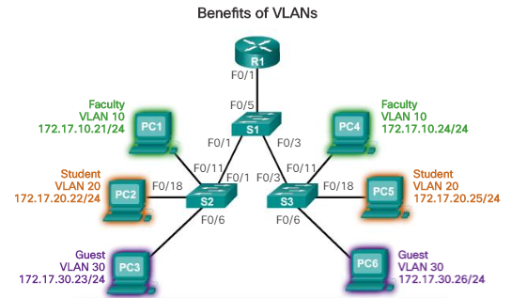

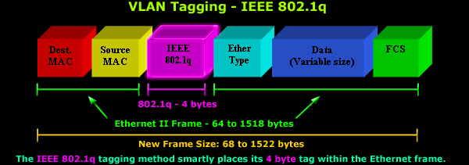

# Simulation

First mockup the lab in the Packet Tracer simulator. Be sure to use 3650-24PS switches. Note that you will have to insert an AC power supply module before the switch will power on.

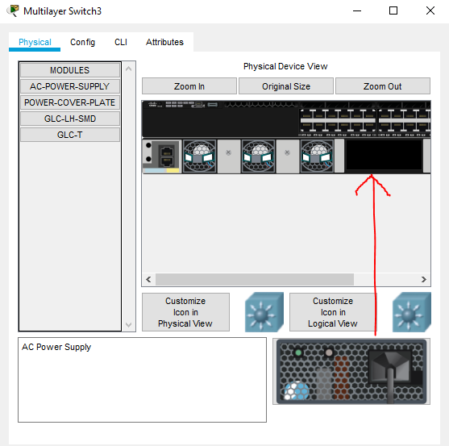

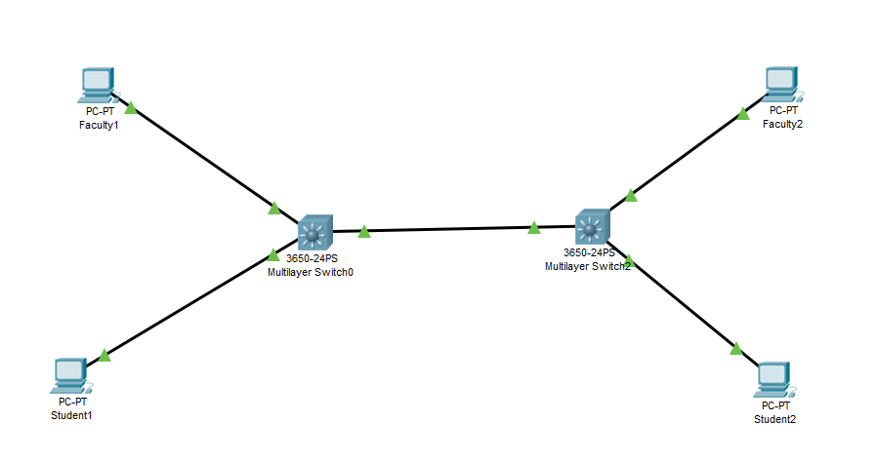

On both switches create vlan 10, Faculty, and vlan 20, Student  
conf t (required before all statements in this section, omitted hereafter.)  
vlan 10  
 name Faculty

On the switch ports connected to faculty computers, configure those ports to be in access mode with vlan 10.  
int g1/0/????  
switchport mode access  
switchport access vlan 10

On the switch ports connected to student computers, configure those ports to be in access mode with vlan 20.  
int g1/0/?????  
switchport mode access  
switchport access vlan 20

Configure the ports that connect the two switches in trunk mode.  
int g1/0/????  
switchport mode trunk

Draw the network on the board and select IP addresses for the PCs. Make sure the Faculty PCs are on one network and the Student PCs on another. Reserve one IP address for each vlan that will belong to a switch; will configure that later.

Configure the IP addresses on the PCs.

Use the show vlan brief command on each switch to see the vlans and which ports are assigned to vlans. Hopefully this matches your design.

If there are no errors the Faculty PCs should be able to ping each other, and the Student PCs should be able to ping each other. The Faculty PCs should not be able to ping the Student PCs and vice versa. WHY???

Configure **one** of the switches to be a router. Tell it that it will be a router, then configure interfaces for the 10 and 20 vlans. Note that the statement, interface vlan 10 (or whatever) actually creates the vlan interface if the interface doesn’t exist yet.  
ip routing  
int vlan 10  
 ip address ???.???.???.??? 255.255.255.0  
 no shutdown  
vlan 20 is the same.

If there are no errors, all PCs should be able to ping each other. Don’t be surprised if it takes a couple of attempts to wake everything up.

Look at the results of show ip route on the switch that you assigned to be the router. It should look just like what you saw from the 2811 routers in the last lab.